JutsuLock: A Convenient and Secure Keyless Entry System using Unique Hand Signs

Chua Yue Zhi, Russ (1001498), Loy Shi Wei (1001450)

Toh Wei Qi (1001862), Abdullah Bin Rawshan (1000751)

**Abstract:** This paper introduces a novel home automation security mechanism as part of a smart nation initiative. The device employs hand-gestures to secure and unlock a hostel room door, combining the personal touch of a thumbprint with the portability of an access card.The idea was inspired from the Jutsu hand-signs used in the anime, Naruto. The product uses a Raspberry Pi camera to capture the hand-gesture, then processors the image on an Intel Movidius Stick, before transferring a bluetooth signal to an Arduino board. The Arduino Board then controls a motor secured using a custom-made motor mount, to lock or unlock the door. The Intel Movidius Stick is trained on a Caffe model on Ubuntu 16.04, based on a dataset created using the hand-gestures of our own team members. Experiments show that our design is able to recognise gestures with high accuracy.

Keywords: Component, Smart Nation, Security, Raspberry Pi, Movidius Stick, Jutsu, IoT, Deep Learning, Ubuntu, Smart Campus, Naruto, Home Automation.

# Introduction

Hostel security is an issue that is often overlooked by many. Recently however, the National Day hostel break-in incident at SUTD has prompted the community to reconsider how a better security system could be enacted. Since Career Preparation is a course that trains students in image detection and other deep learning technologies, Group 1 was motivated to find a useful solution to address this. Our project in particular will relook at hostel door locks as these serve as the main line of defence against intruders

Traditional security measures such as keys and cards have the advantage of being transferable because it is physical. However, most students will choose to avoid bringing their cards with them to the toilet due to hygiene reasons. Conversely, modern security methods such as face or voice recognition scanners do not depend on physical items, but lack the transferability advantage that traditional keys can offer. In such cases, modern system can be tough to work with when the residents of the room changes. More training on the new residents would have to be done in order to install their profiles into the system.

In our project, we look at how hand signs can be used as a transferable modern security option. By selecting hand signs that are niche and difficult to reproduce for those who are unaware, our group has created a robust system that works only to the benefit of the hostel room occupants and to those they permit entry to.

1. Concept

Sealor Hand Signs are used to perform many ninjutsu, genjutsu and other secret acts in the popular anime series Naruto. They are designed to summon or mould chakra to perform a technique. For example, the popular Shadow Clone Technique (影分身の術, Kage Bunshin No Jutsu) allows the user to create one or more copies of themselves. Since there are different sequence of hand seals for different techniques, it requires memorisation. As such, this application can be used for security purposes e.g. replacing passwords or access cards.

For using this concept, we decided to “invent” our own “ninjutsu” also known as Shadow Door Opening/Closing Jutsu for secure keyless entry. While the prototype JutsuLock that we invent can only detect two hand signs, such as Boar or Bird, more sophisticated hand signs can be incorporated such as requiring a longer chain of hand signs in order to perform a specific operation. In this application, we attached our door knob to the door that is being powered by a motor. Once the correct hand sign is being shown at the camera which is connected to a Raspberry Pi, the door unlocks, granting the user access into the room.

# Prototype Development

The prototype JutsuLock is made up of three main components, which are its mechanical structure, data communication systems, and its software implementation. The prototype consists of two parts to be placed inside and outside of the occupant’s room as shown in Figures 1,2 and 3.

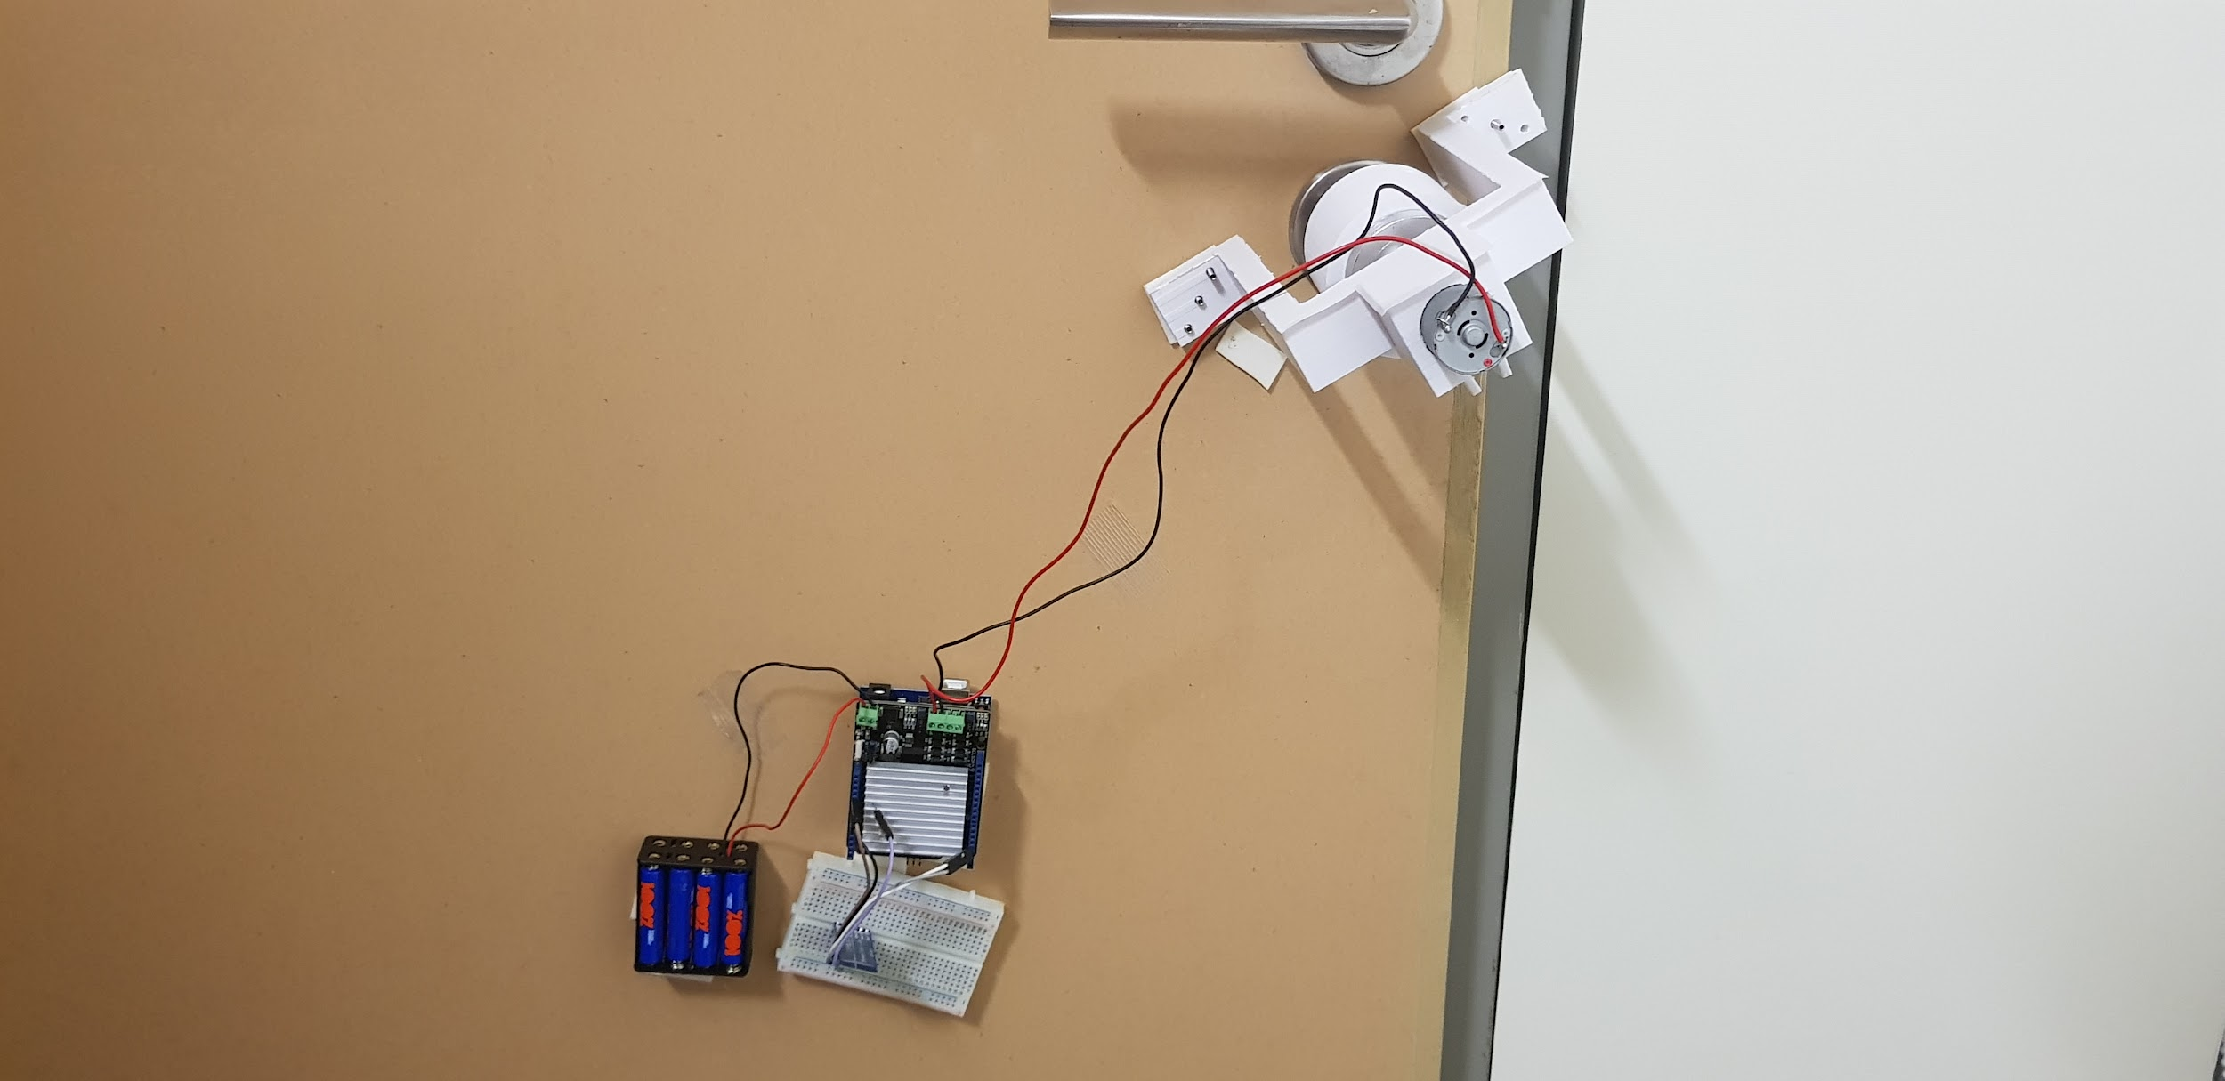**Figure 1.** JutsuLock from inside the occupant’s room

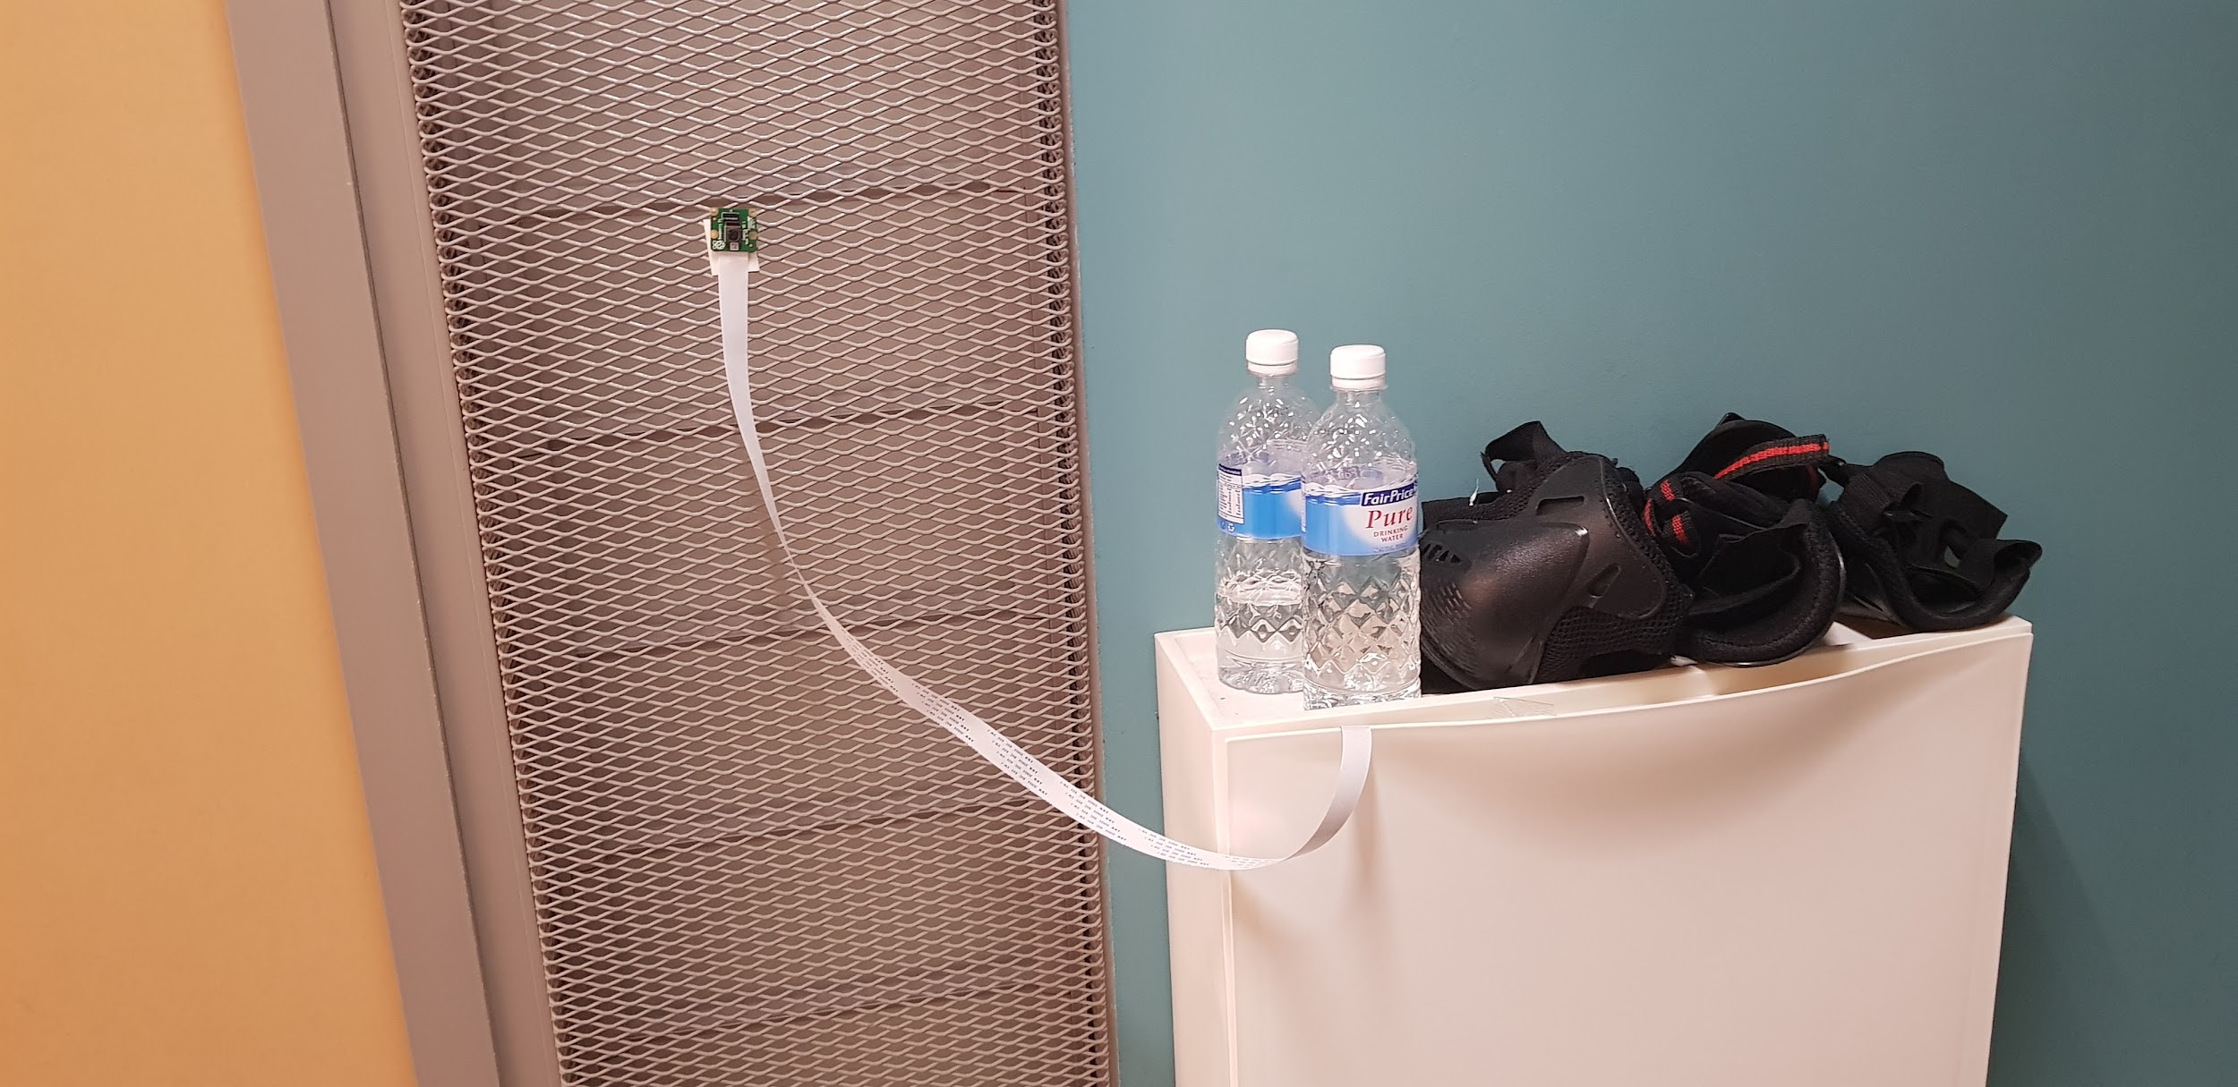**Figure 2.** JutsuLock from outside the occupant’s room

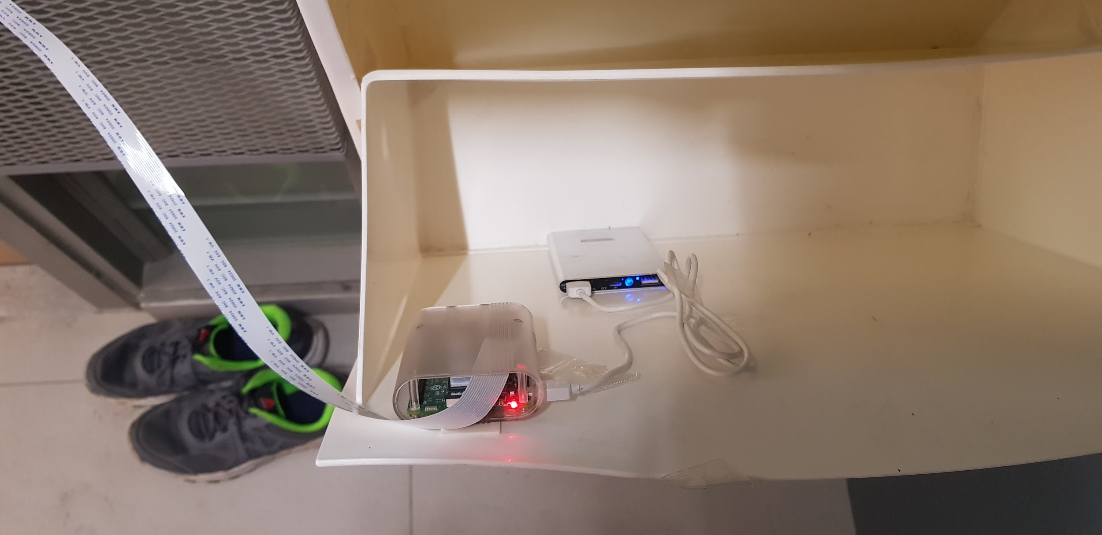

**Figure 3.** JutsuLock Electronics in the occupant’s shoebox

The crucial door unlocking mechanism is located on the inside of the door because a card is not required to turn the locking latch from inside. Meanwhile, the Arduino is powered by 8 AAA batteries through a motor driver shield. JutsuLock’s electronics were designed to fit within the SUTD hostel occupant’s shoebox and be powered by a portable USB charger. The two microcontrollers communicate to each other via a HC-05 Bluetooth module.

1. Mechanical Structure

Like many home door systems, the SUTD Hostel doors can be unlocked/locked remotely from the inside without the use of keys. To demonstrate the function of our prototype, we designed a custom motor-door mount for the SUTD hostel door for remote opening and closing of the hostel door lock shown in Figure 4 below.

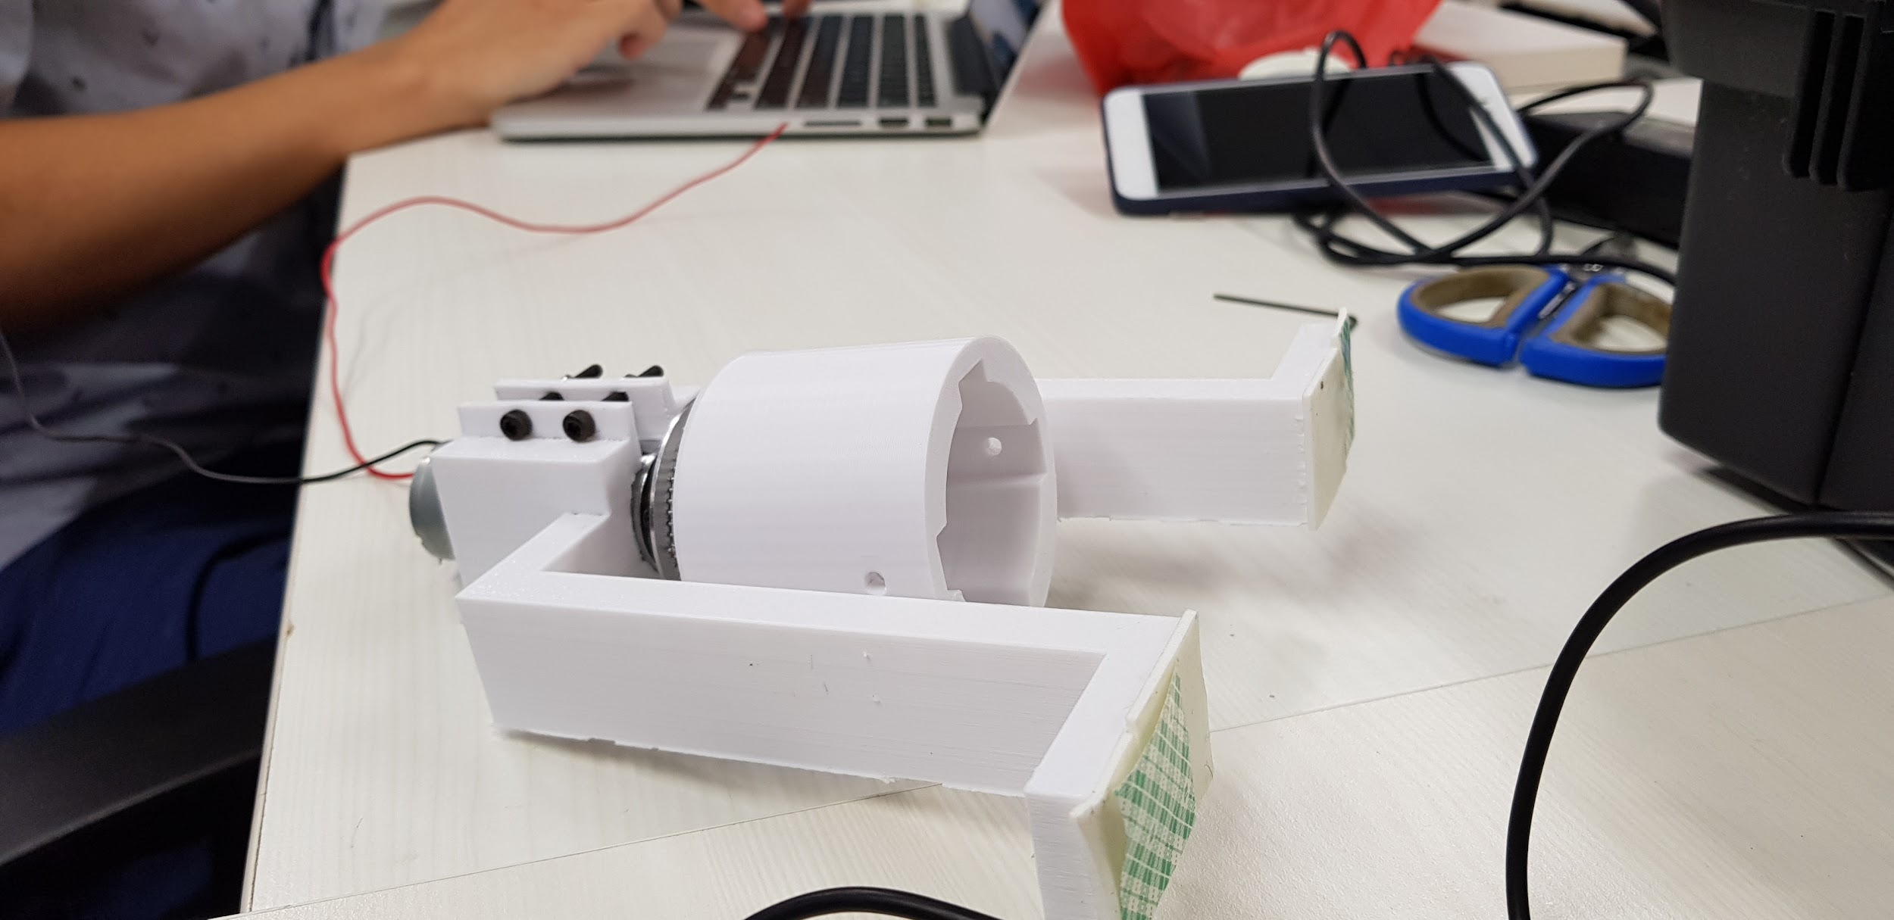**Figure 4.** Motor-door mount

We experimented with other designs such as one that involving using a belt connected in tension to the door knob. However, we found that slipping occurred between the belt and the door knob, and hence opted to connect the motor directly to locking knob via the motor-door mount.

The motor-door mount itself comes with two components, the first being the door mount which fixes the motor with respect to the door and ensures that the motor does not rotate as its axis turns. The second component is the coupler, used to transfer torque from the motor to the door lock.

|  |  |
| --- | --- |
| **Figure 5.** Door Mount CAD | **Figure 6.** Coupler CAD |

1. Software Implementation

Computer Vision using a Raspberry Pi with an Intel Movidius Stick

The system is trained on a Caffe Model on Ubuntu 16.04. We took photos of all our members performing hand signs and used multiple filters to ensure that our model would work across multiple light settings as shown in Figure 7. After producing the Caffe graph, we ported it to the Raspberry Pi + Movidius Stick and found that we also achieved high accuracy through the camera feed shown in Figure 8.

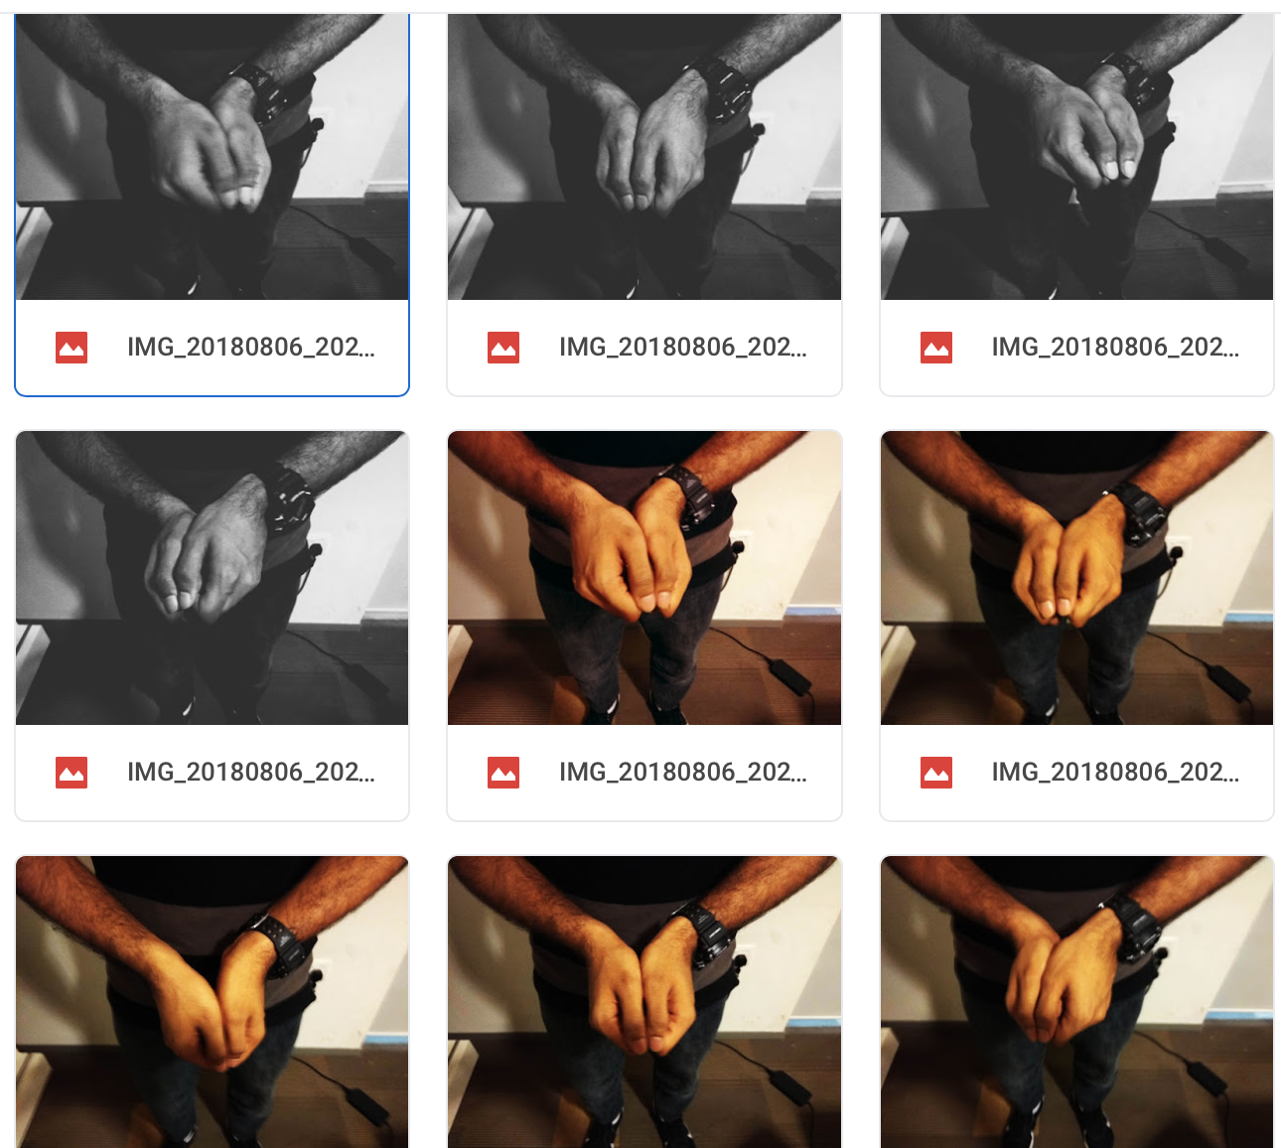

**Figure 7.** Hand sign photographs for training

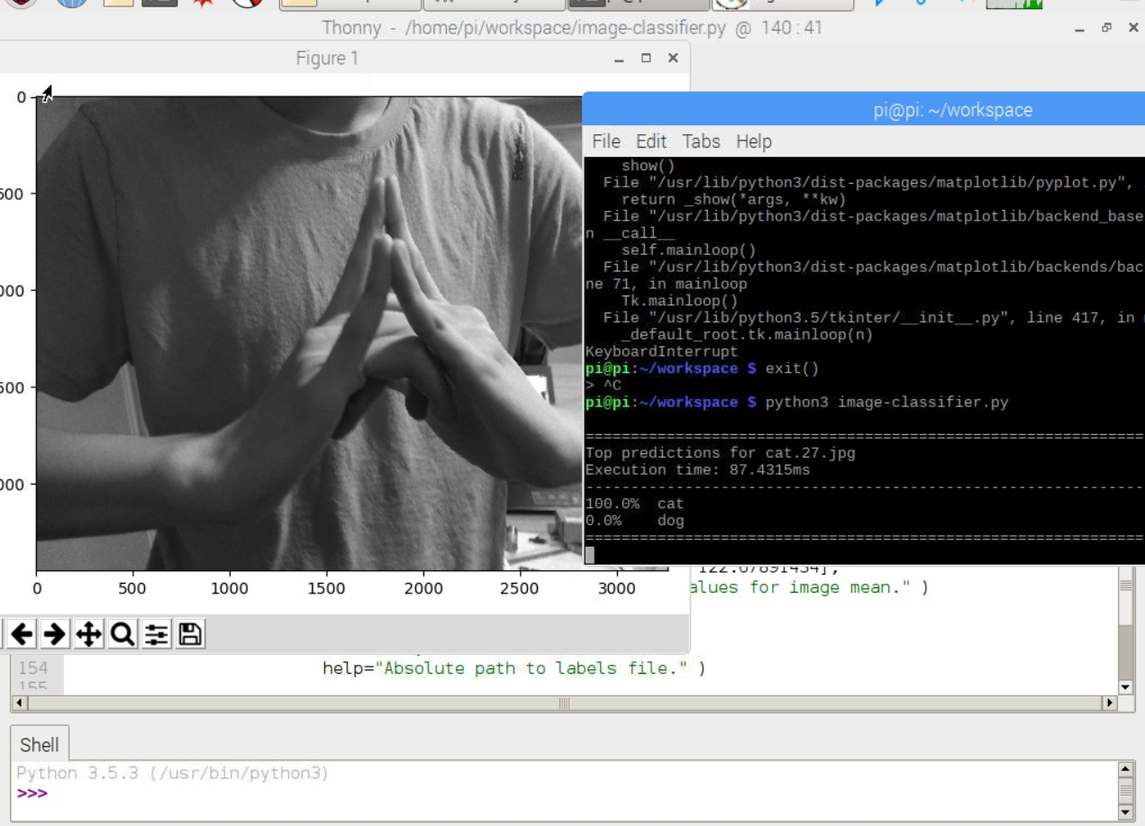

**Figure 8.** Hand signs have high accuracy

Software-controlled locking and unlocking

We used the Arduino microcontroller to process the output from our hand-sign detection system and control the movement of the motor using a simple Finite State Machine. The state diagram is as shown in Figure 9 below.

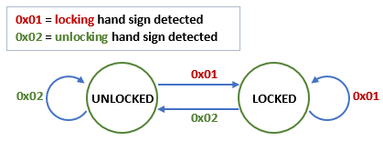

**Figure 9.** State diagram for the operation of the JutsuLock

Locking and unlocking the door involved turning the motor either clockwise or anticlockwise for a fixed duration of 5s.

By checking the state of the lock, we can apply logic to prevent the JutsuLock from attempting to unlock when the door is already locked; likewise, it will not attempt to lock when the door is already locked. This will prevent the motor from turning past the allowed limit which may damage the mechanical structure of the lock.

1. Network Architecture

For operation of the JutsuLock, the results from the computer vision-based hand sign detection program must be communicated from the Raspberry Pi to the Arduino-controlled motor. To achieve this data transfer, we set up a Bluetooth connection between the Raspberry Pi and the Arduino. Bluetooth technology was chosen as the preferred data transfer medium as it is low-cost, wireless, and with a suitable connection range of approximately 10m.

The Raspberry Pi also comes with a built-in Bluetooth module, which will allow the Raspberry Pi installed outside of the door to effectively send its data to the Arduino-controlled lock mechanism located at the interior of the secured room without additional hardware for the Raspberry Pi. On the Arduino-end, a HC-05 Bluetooth module was used to set up the bluetooth connection.

Figure 10 shows the data communication network architecture.

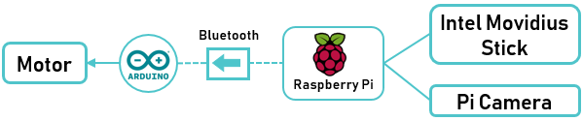

**Figure 10.** JutsuLock data communication network architecture

The Raspberry Pi acts as a client and automatically initiates a Bluetooth connection to the Arduino server when the main programme is run. The code also allows the Raspberry Pi to reestablish the connection in case of a disconnect.

Serial protocol was used for data communication over Bluetooth. The Raspberry Pi pushes its data to the Arduino by sending it the byte ‘0x01’ when a Boar hand-sign is detected, or the byte ‘0x02’ when a Bird hand-sign is detected. The serial buffer is then flushed after each unlock/lock of the JutsuLock.

The data transmission network was successfully implemented in the JutsuLock.

# Test Results

Through our tests, we found that most images would rank highly on the hand sign with regular pictures scoring as high as 75% confidence on either hand sign. Because the model was only trained on two hand signs, this meant that our threshold acceptance value would have to be high for both hand signs. Through testing, it was found that a high threshold value of 96% would work well for our needs.

Yet in order to make the image recognition system more robust, it should be trained on more images outside of both hand signs. This would allow it to better differentiate the markers that we are looking for, and minimise the risk of a false positive result.

# Conclusion

We have successfully implemented the JutsuLock and verified its use as a novel way of locking and unlocking the door. While current security measures such as traditional mechanical keys and more modern facial recognition systems are good at preventing unwanted intruders, the JutsuLock offers a novel, convenient and efficient way of they securing ones belongings. Overall, JutsuLock successfully combines the personal touch of a thumbprint with the transferability of a key card.

# Future Work

The current version of JutsuLock works with two symbols, boar and bird, one for locking and the other for unlocking the hostel door. In future, our algorithm could be modified to include a variety of hand gestures. The same principle could also be modified to include a variety of applications, such as securing car doors, safes, etc.

Furthermore, the algorithm could be modified to work with a combination of gestures in order for one to open the door. Hence, this will definitely increase the security as compared to our current work which is only detect only 1 hand sign. For example, if you want to open a door, you can enter a 7 hand sign combination, which is quite similar to the 7 digit passwords/phrase that we are familiar with today.

Thus, JutsuLock can serve as a complement to traditional passwords or a fun way for unlocking doors. Furthermore, it also can be used for hand sign recognition for transcribing and translating purpose with the deaf therefore making them feel more inclusive and breaking down barriers. One last application will be it being used in theme parks or games to allow people to cast their “magic” to unlock certain purposes.

##### Acknowledgment

Special thanks to Prof Tee Hui and the ARMS lab staff for this project, Intel for the Movidius NCS, Raspberry and the numerous researchers who created the Caffe model to allow people to work on such projects.

##### References

1. G. Eason, B. Noble, and I.N. Sneddon, “On certain integrals of Lipschitz-Hankel type involving products of Bessel functions,” Phil. Trans. Roy. Soc. London, vol. A247, pp. 529-551, April 1955.